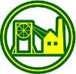Dear Parents/Carers, welcome to a new term. Please find below a brief overview of the Year 3 curriculum that your child will be learning during Spring Term.
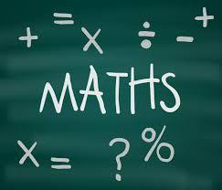 | Maths – Number – Multiplication, Division and Fractions, Measure – Money, Length, Perimeter and Statistics.  Your child will also complete Mathstastic, Times Tables Olympics and Times Tables Rock Stars each week.  Vocabulary – equal group, same as, equal to, share, numerator, denominator, equal part
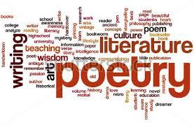 | English - Fiction – The Lion, The Witch and The Wardrobe and Charlie and the Chocolate Factory, which will include: writing their own stories, character descriptions, newspaper reports as well as spelling, grammar and punctuation  Non-Fiction – Big Cats and The Process of Making Chocolate, which will include writing non-chronological reports and fact files.  Vocabulary – cohesion, paragraph, diary, fronted adverbial, main clause, subordinate clause
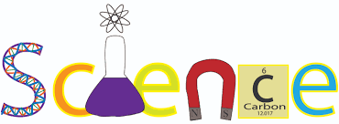 | Science – Animals including humans – Children will study nutrition, balanced diet, types of skeletons and muscles, the requirements of a healthy diet and how this can affect our bodies.  Light and Dark – Children will learn about light and shade and how shadows are formed.  Vocabulary - nutrients, food groups, muscles, bones, skeleton, light, shade, dark, shadow
Computing - Use a database to create a graph. Work with various forms of input.
Vocabulary - database, graph, data, information, programme, input
PE – Invasion Games, Net-Wall Games and the children will have 6 weeks of swimming sessions.
Vocabulary – position, graceful, sequence, team, partner, defence, offence
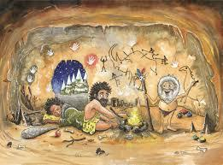 | History – Ancient Egypt  Focus: Key features of early civilisation. Who was Tutankhamun? Where on a timeline did he reign? When were pyramids built? Were they built for a purpose?  The children will have the chance to visit a local museum to further explore the topic.  Vocabulary – Early civilisation, timeline, pyramids, Egyptians, Nile, chronological.
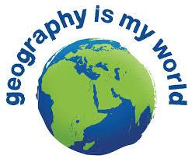 | Geography - UK Discovery – UK Towns and cities  Focus: Countries, counties, land use, settlements, contrasting cities  Vocabulary – settlements, contrast, towns, cities, county, country, continent
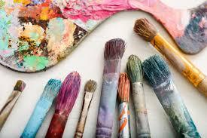 | Art – Children will learn about Hieroglyphics and will write using hieroglyphics. Sketching and studying local artist Norman Cornish.  Vocabulary – brush, stroke, pencil, line, thickness, observational
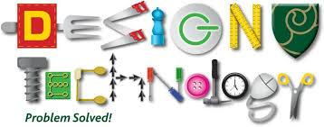 | Design and Technology – Textiles – sewing simple book marks  Egyptian Death Masks – Children will use a range of techniques to create an Egyptian death mask and to understand why Egyptians wore these masks.  Vocabulary – stitch, sew, design, fabric, aida, thread, needle, technique
Music - Glockenspiel Stage 2 and Benjamin Britton – There was a monkey
Children will also be learning songs for the Easter Service.
Vocabulary – instrument, sound, pitch, pattern, tune, song
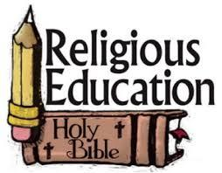 | RE - Christianity - What do Christians remember on Palm Sunday? What can we learn about Christian worship?  Vocabulary – Christianity, belief, religion, church, place of worship, worship, Christian symbols, denominations.
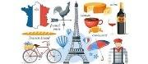 | MFL – French – Colours and Numbers and Fruits
PSHCE - Relationships
Vocabulary – healthy, sharing, caring, together, discriminate, include, exclude, friendships

